**INTRODUCTION:**

JAX-RPC(Java API for XML Based RPC) is a specification that defines the Java APIs for making XML-based remote procedure calls (RPC). In particular, these APIs are used to invoke and get a response from a web service using SOAP 1.1, and XML-based protocol for exchange of information in a decentralized and distributed environment.

JAX-RPC (Java API for XML-based Remote Procedure Call) was subsequently introduced to specify how to write Java web services components for disparate systems using SOAP and WSDL.

JAX-RPC is based on the RPC programming model for invoking operations of a web service. The RPC programming model invokes stubs located on the client to call methods on a remote server.

Basics of RPC will be covered in theory.

Example of middleware : remote procedure call (RPC). RPC is the basis for middleware systems used for certain web services.

RPC allows clients to invoke procedures that are implemented on a server. In RPC, the client and server are either: 1. on completely separate machines 2. are a different virtual instance on the same machine

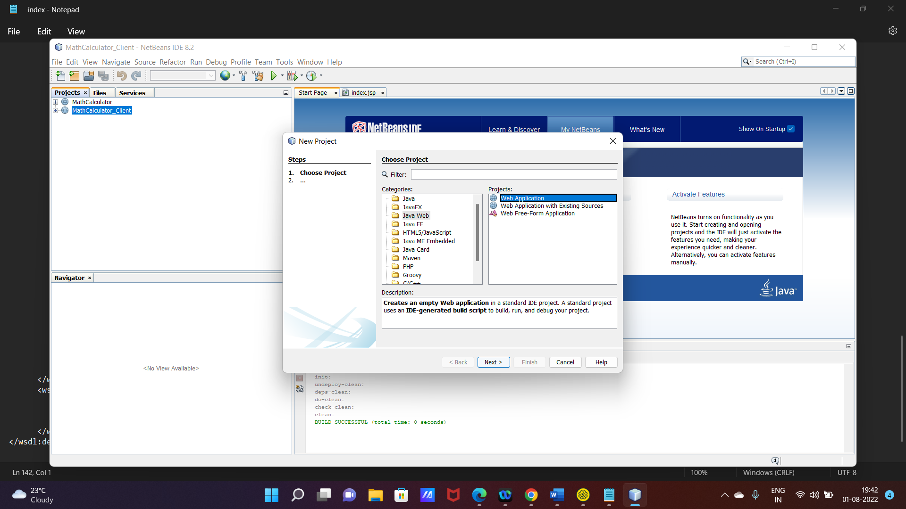

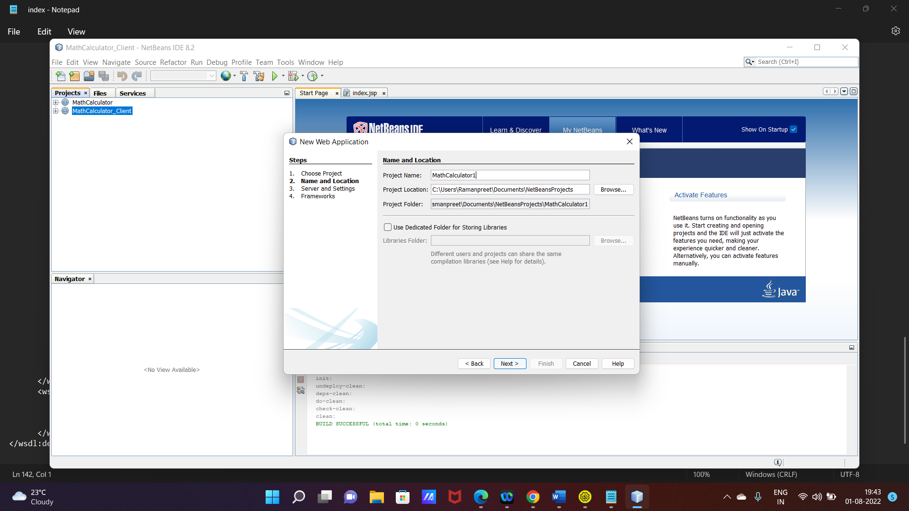

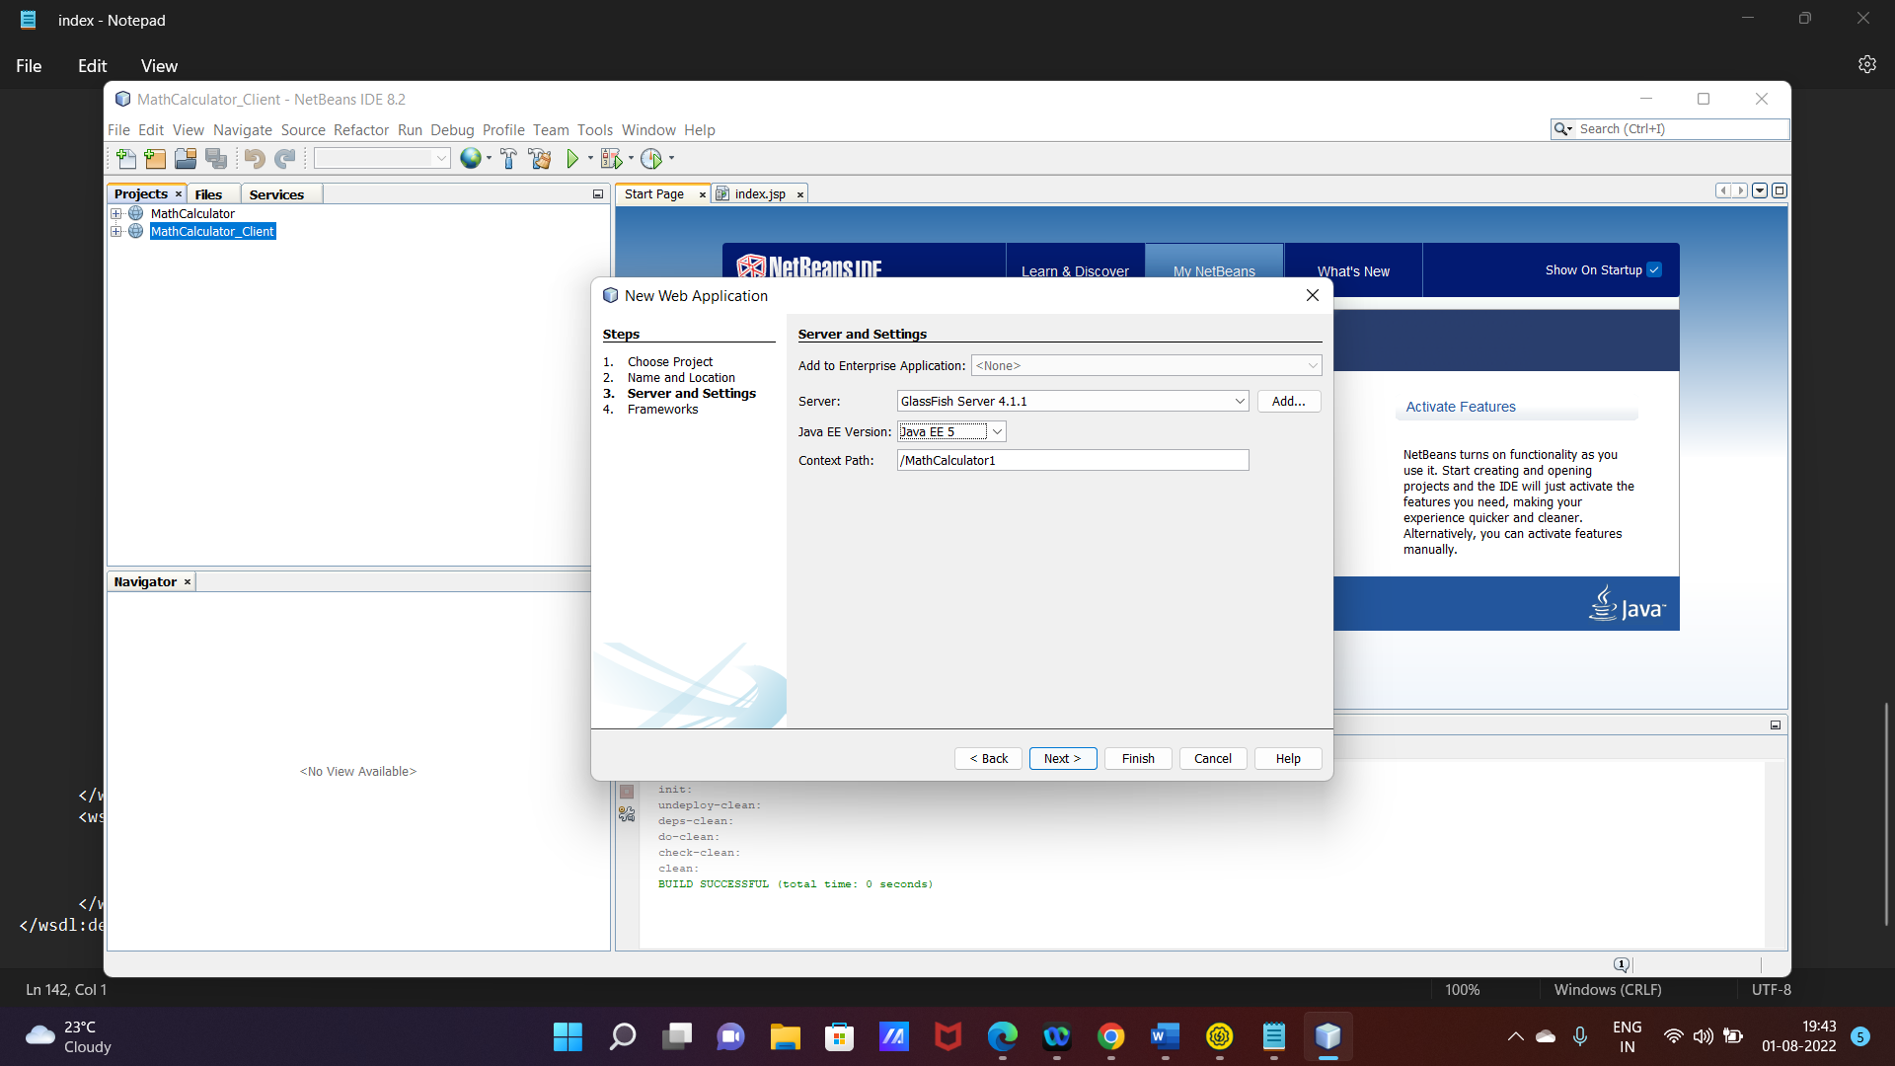

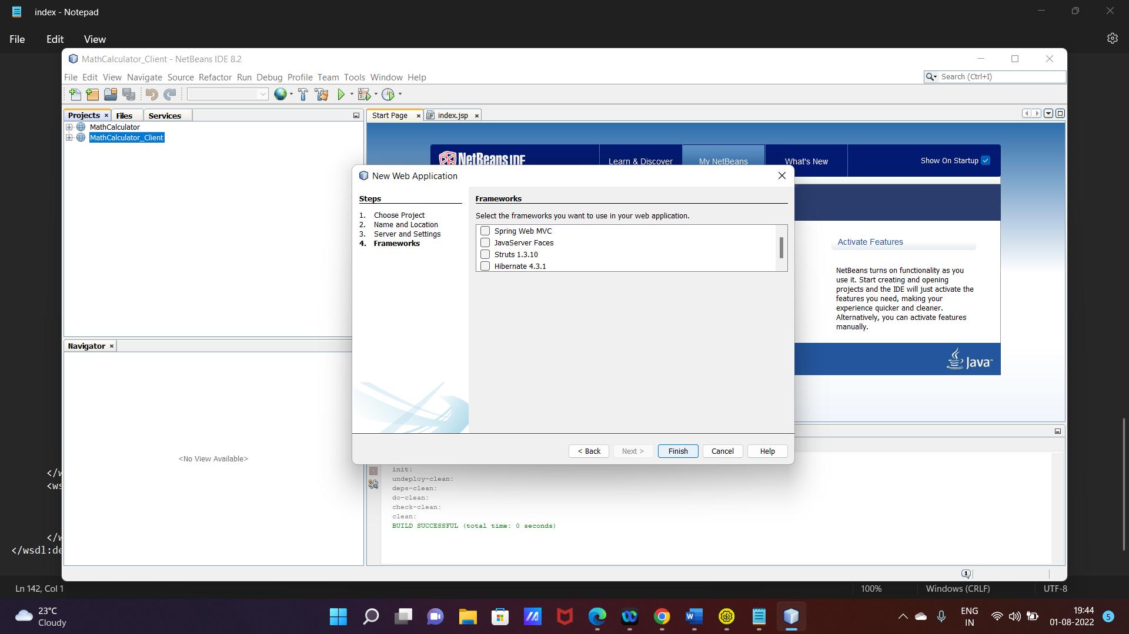

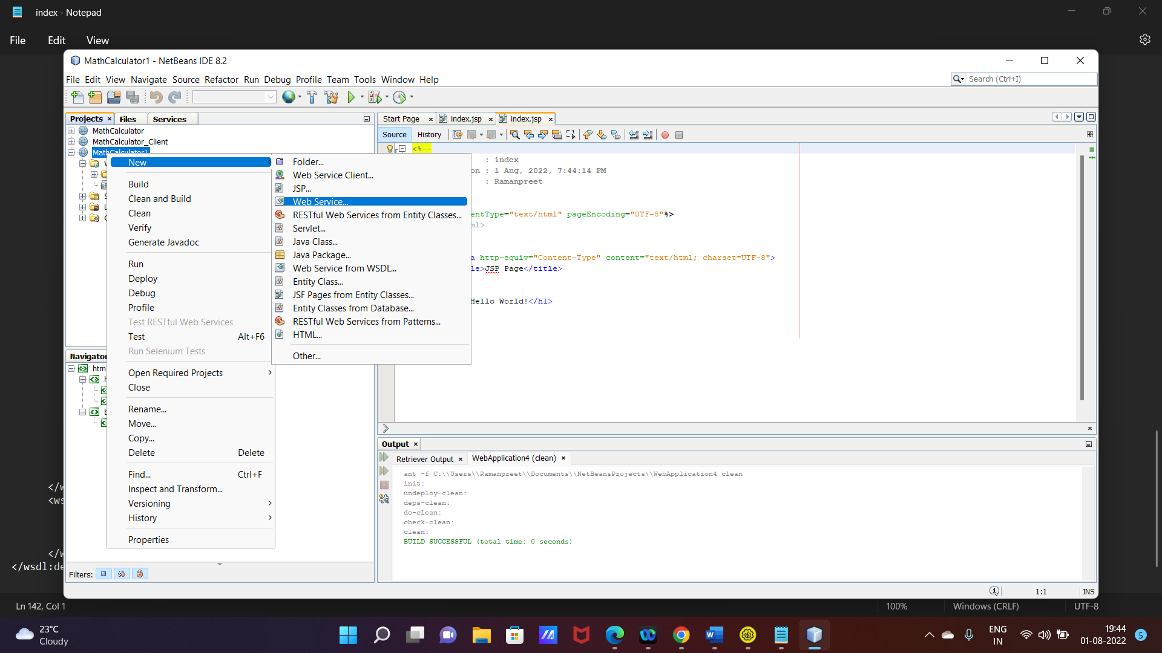

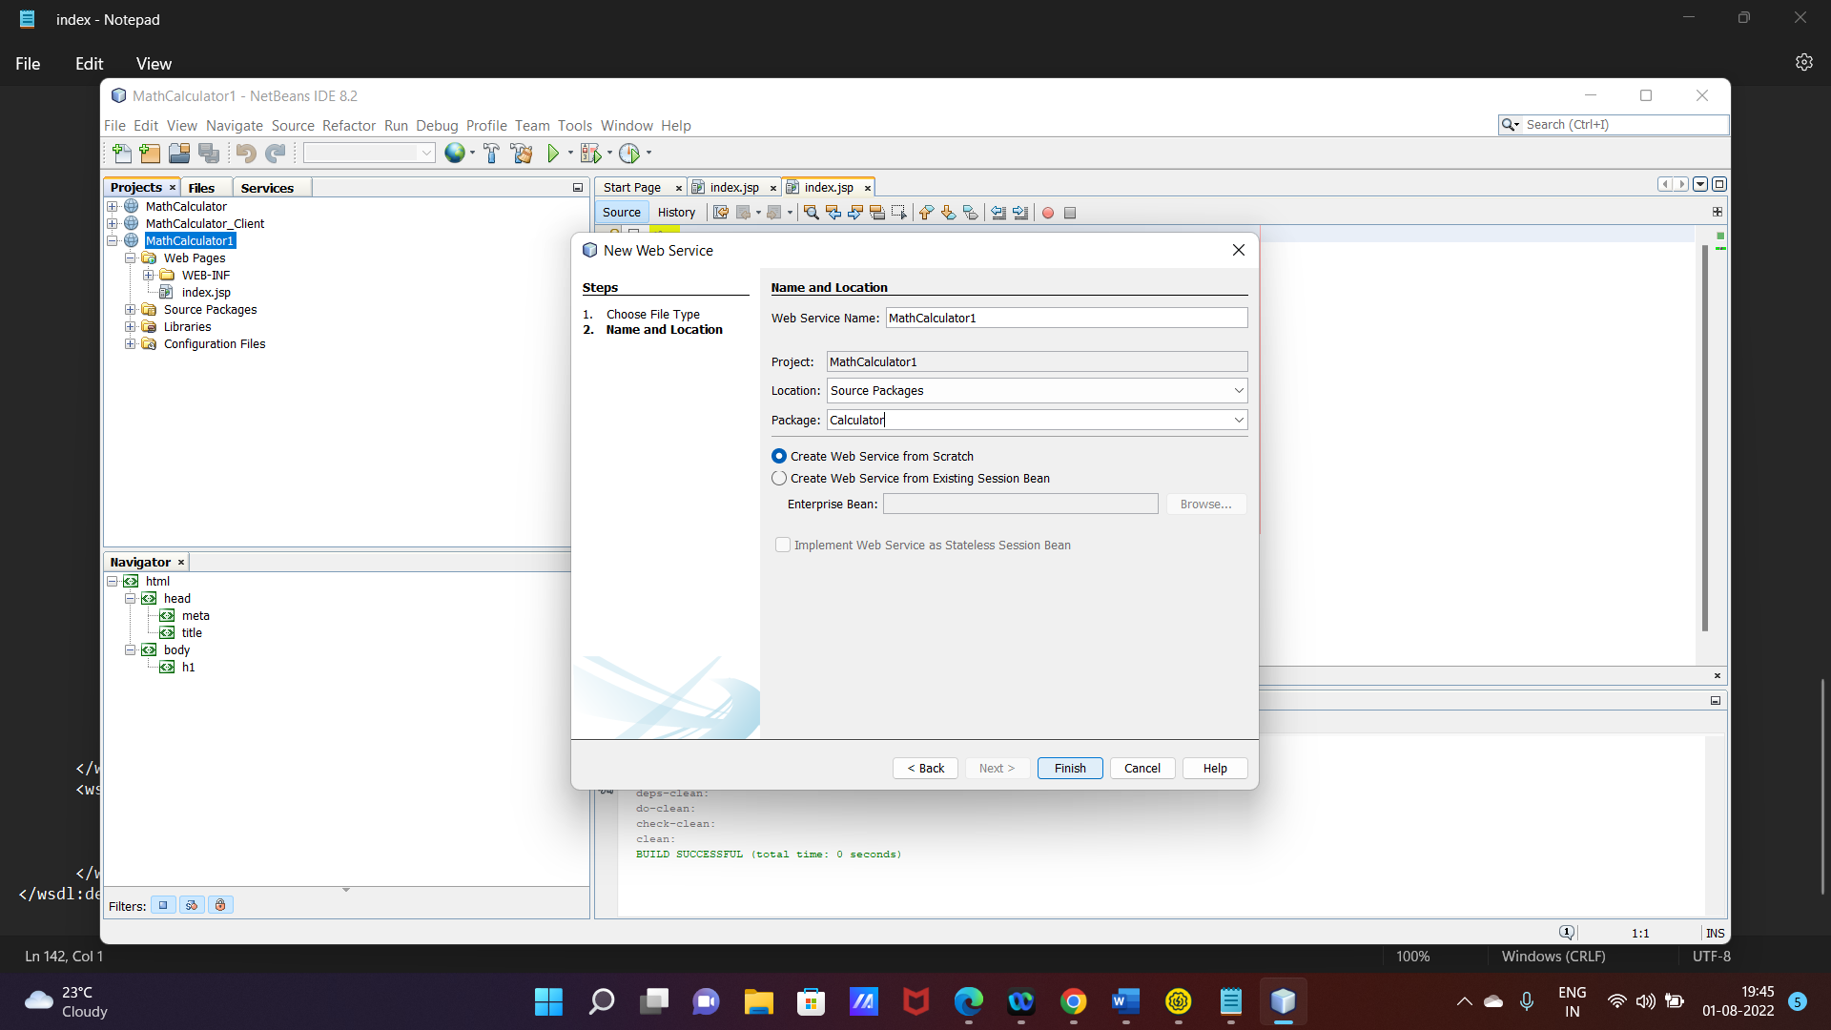

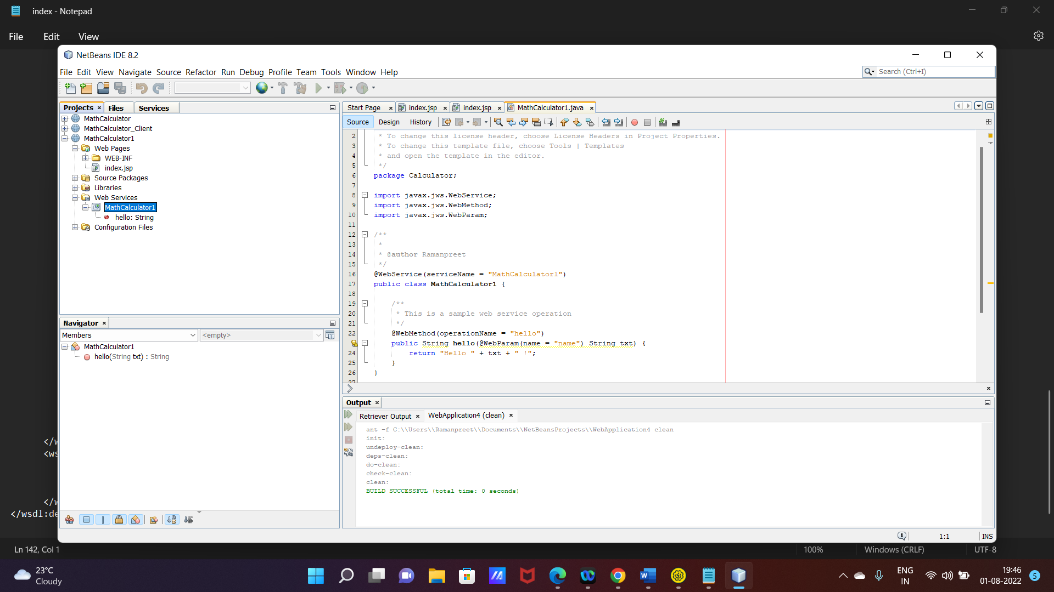

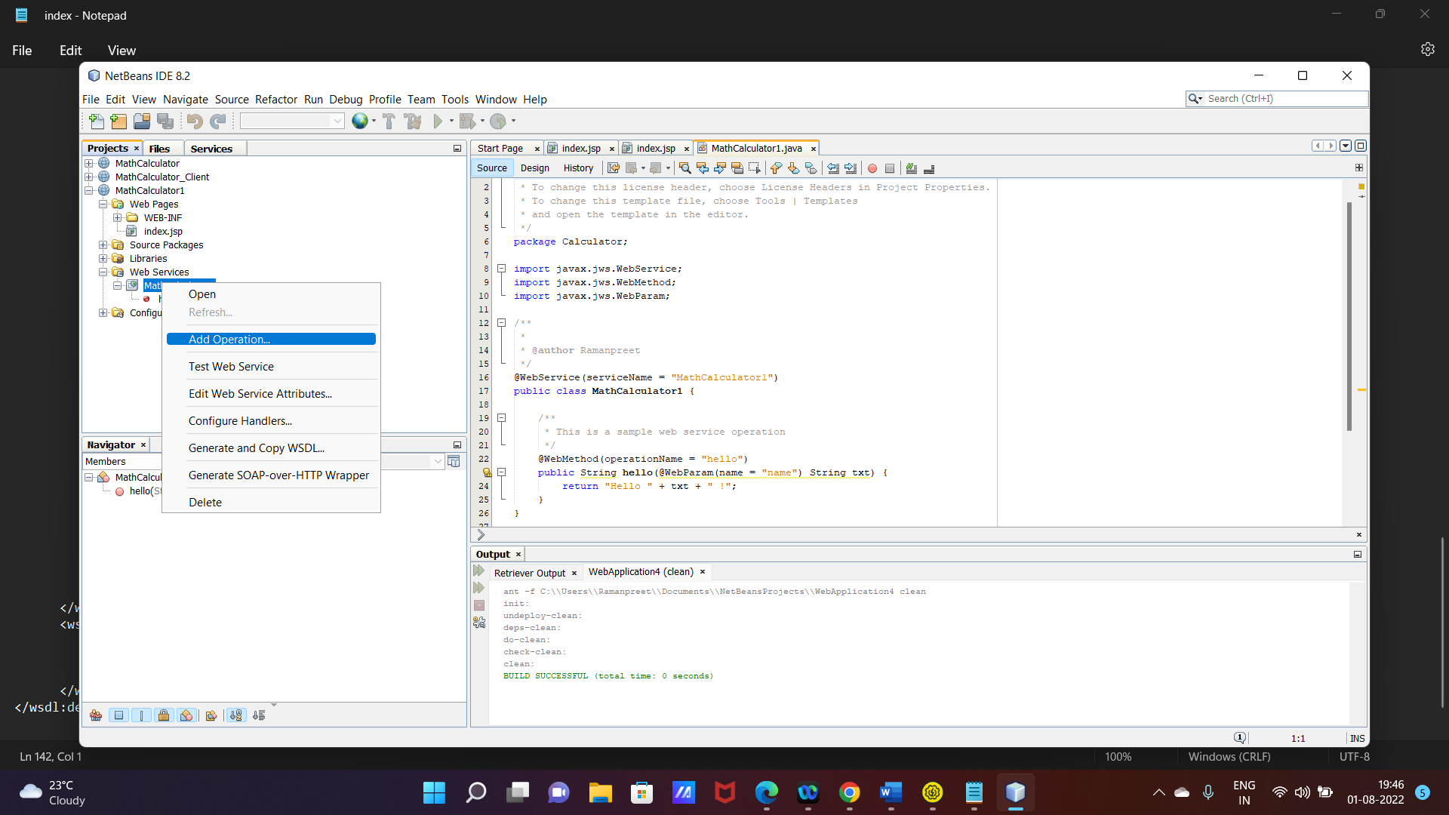

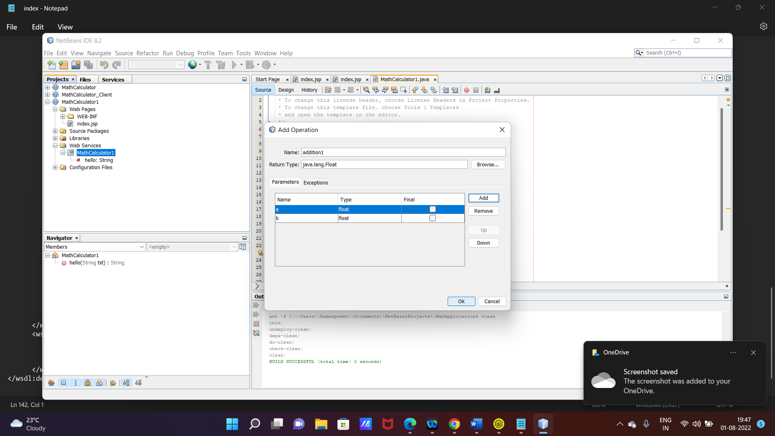

Work on index.jsp

<form action="Calculate">

Enter a number :<input type="text" name="a">

<br>

Enter a number :<input type="text" name="b">

<br>

<input type="submit" name="type" value="addition1">

<br>

<input type="submit" name="type" value="subtract1">

<br>

<input type="submit" name="type" value="multiply">

<br>

<input type="submit" name="type" value="division">

</form>

Change return type in java file

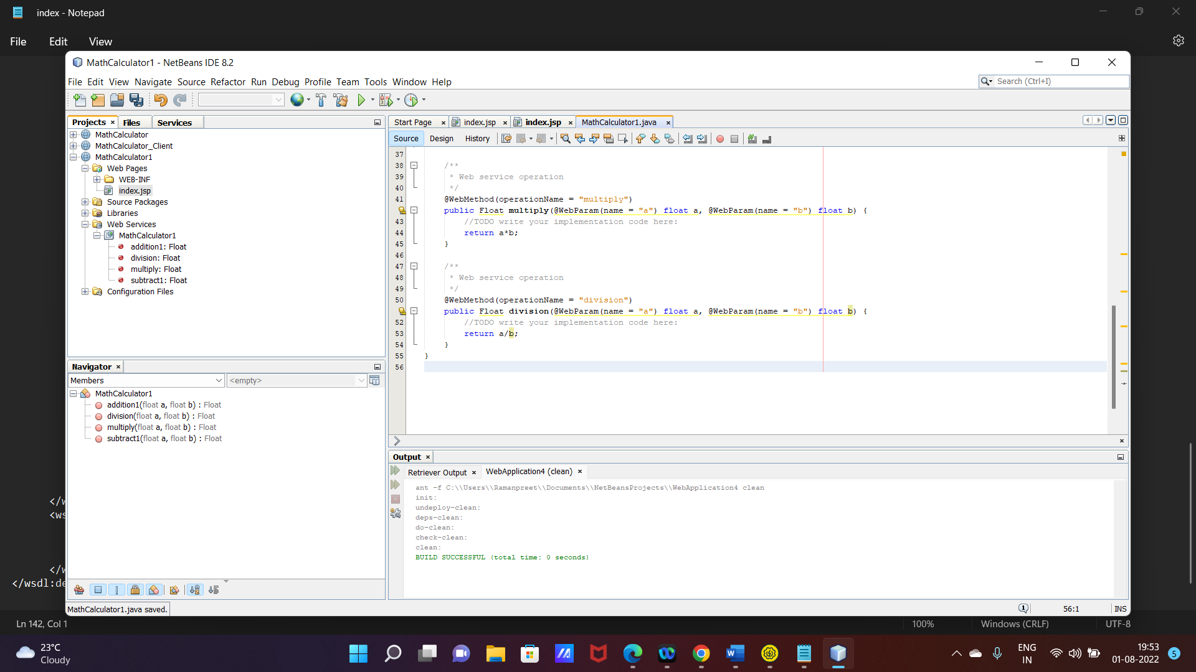

Deploy webservice

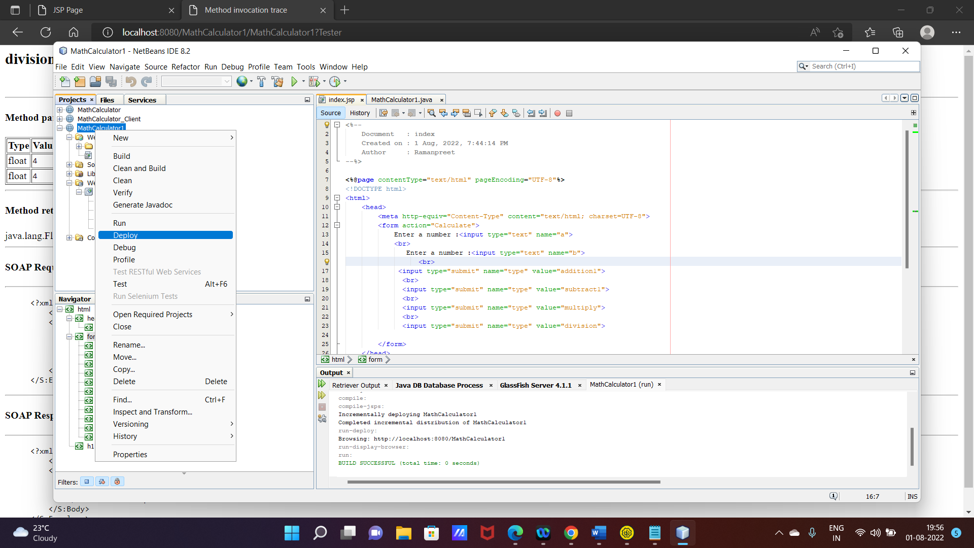

Test Web Service

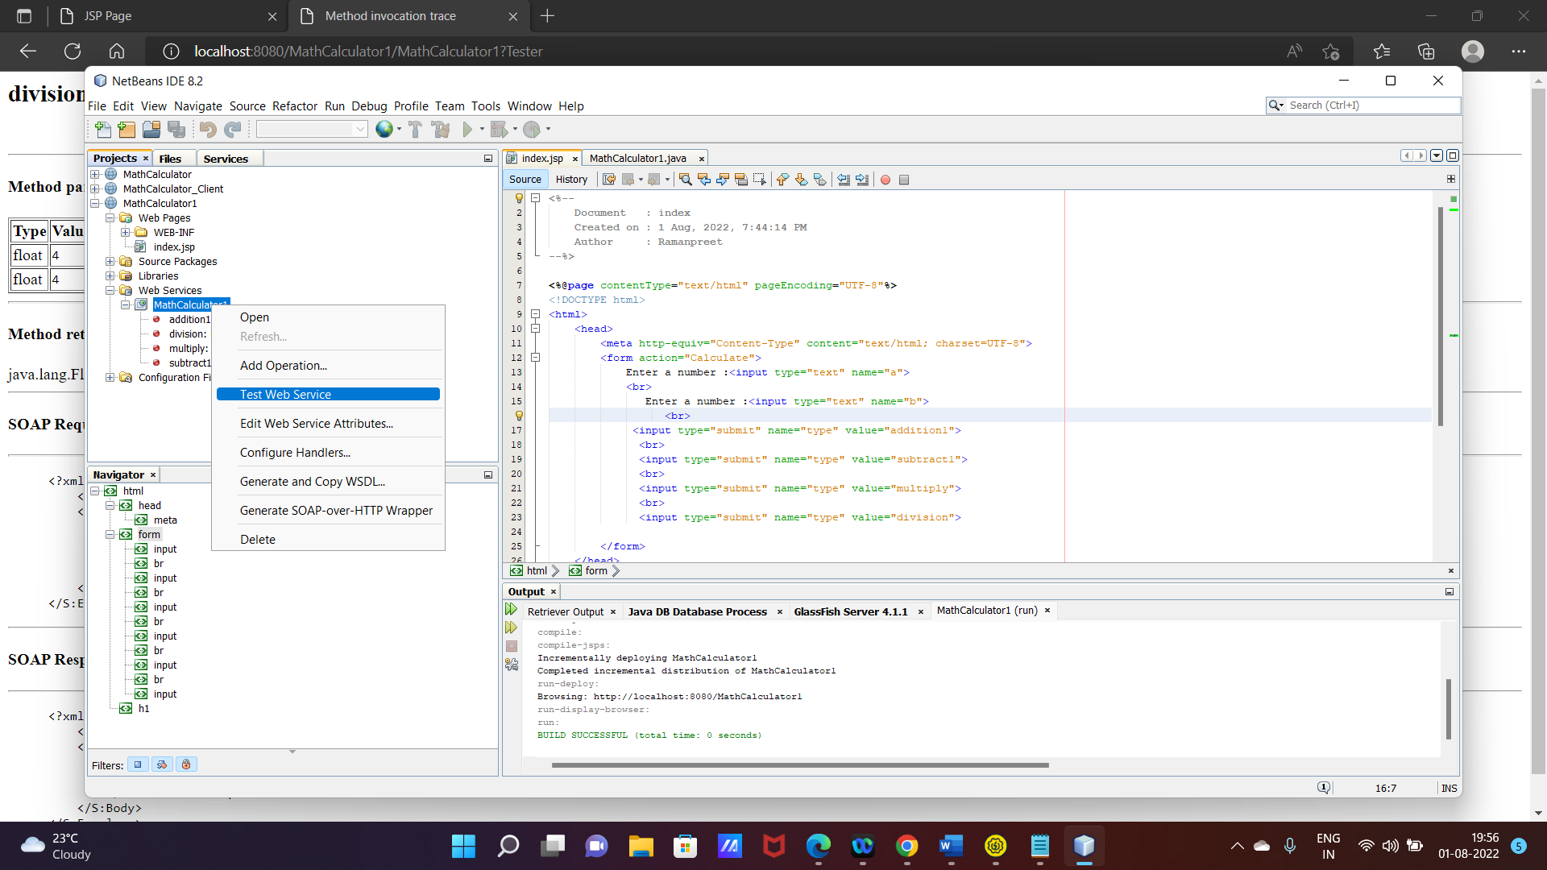

Tester file opens when clicked on test web service

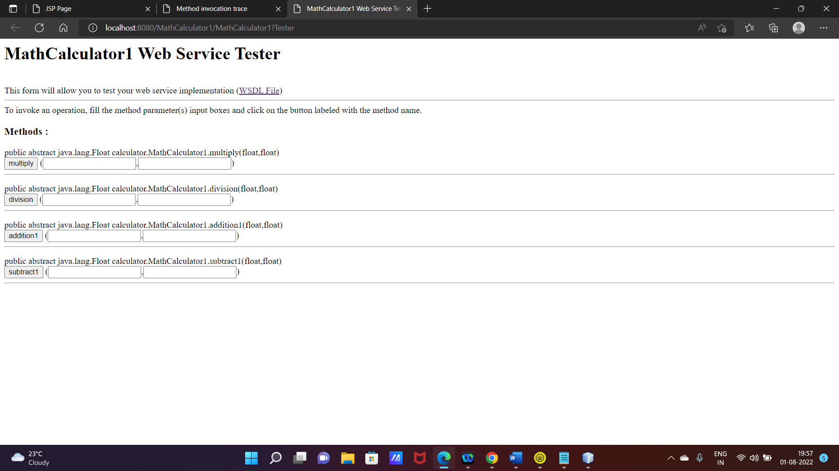

Copy the link of WSDL file

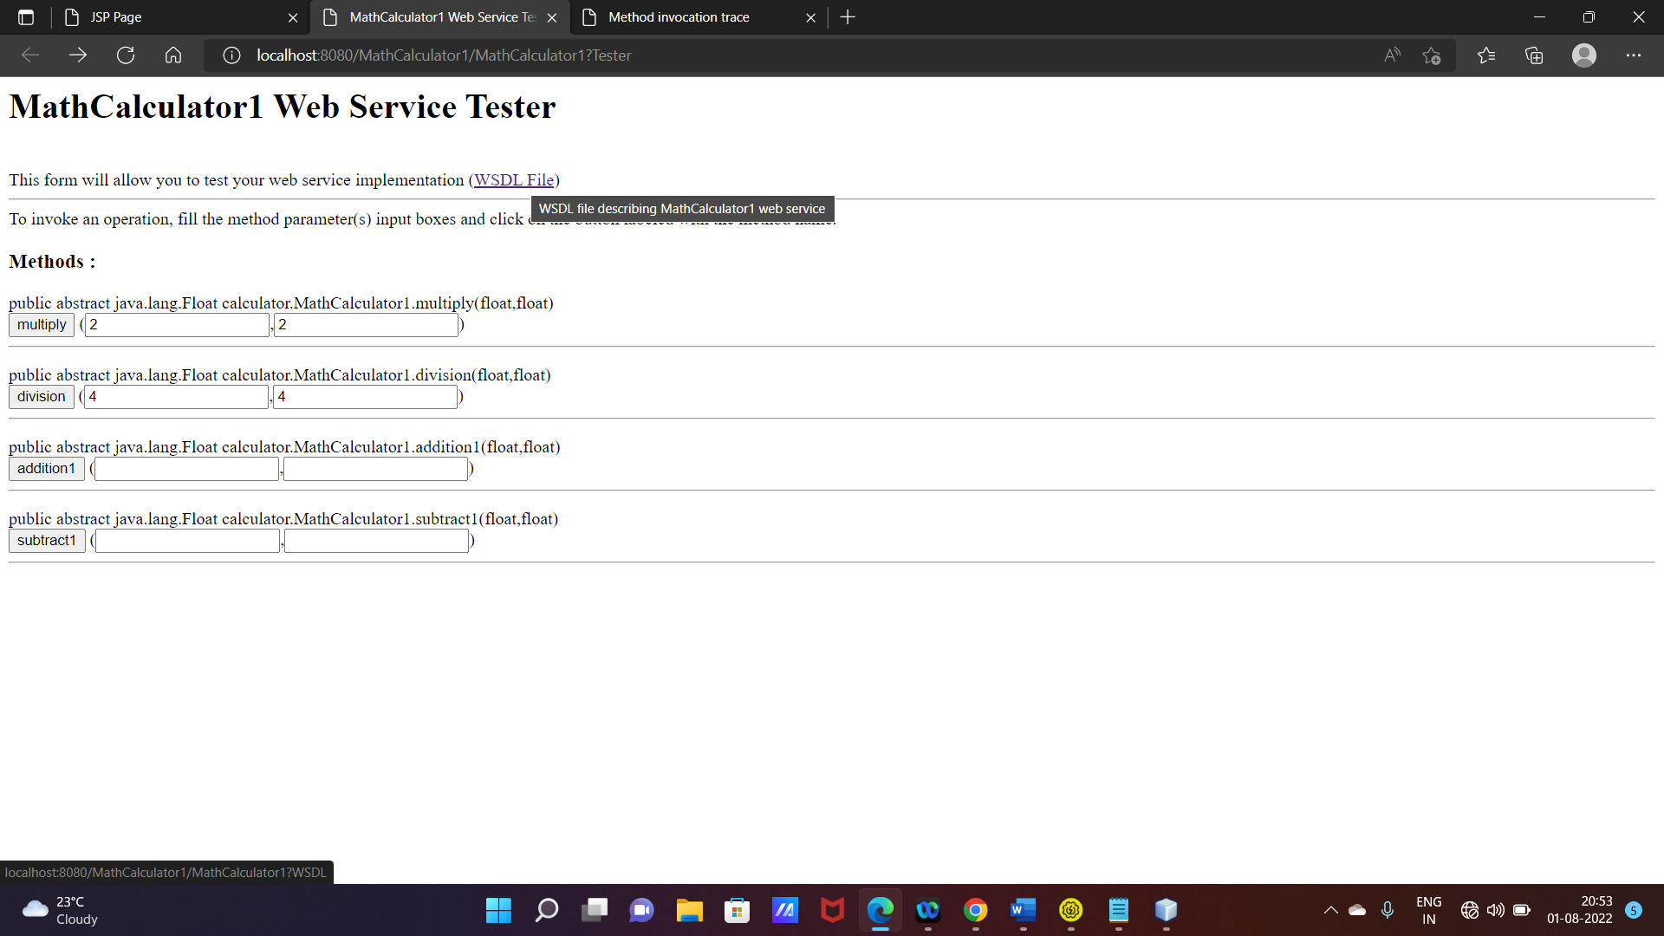

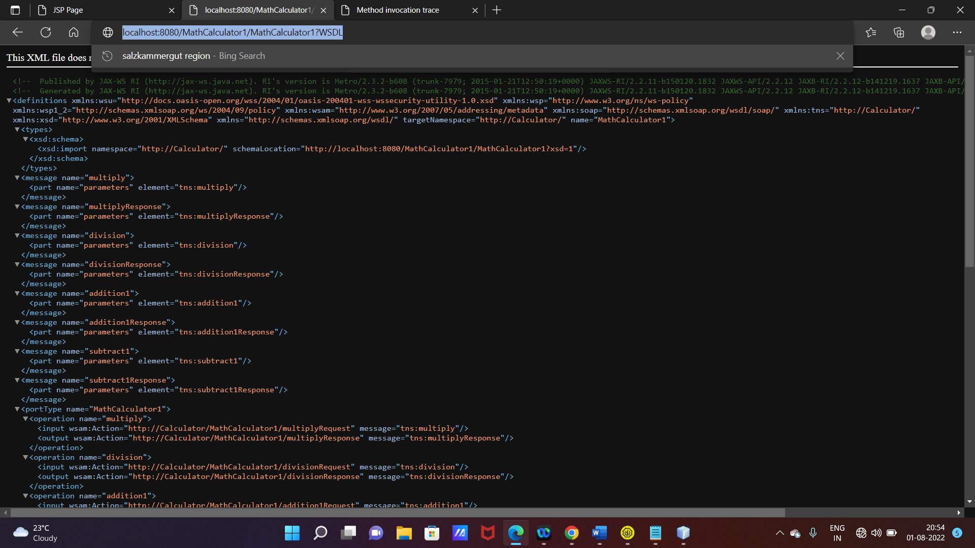

[localhost:8080/MathCalculator1/MathCalculator1?WSDL](http://localhost:8080/MathCalculator1/MathCalculator1?WSDL)

Similarly create client web app.

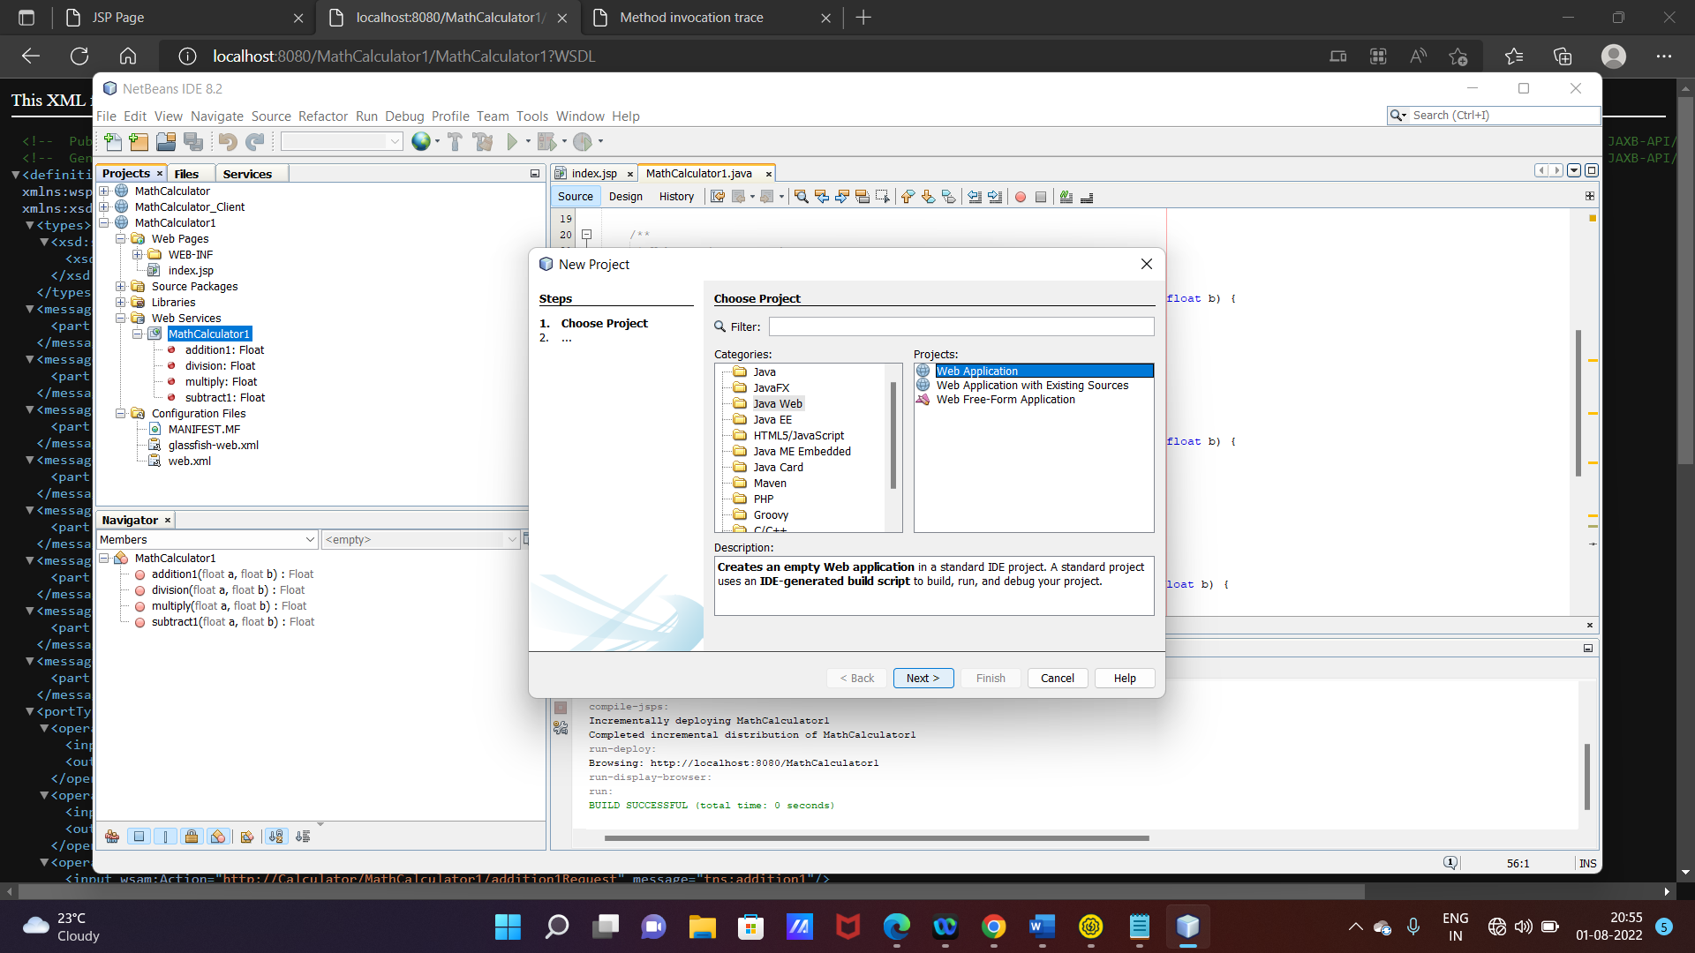

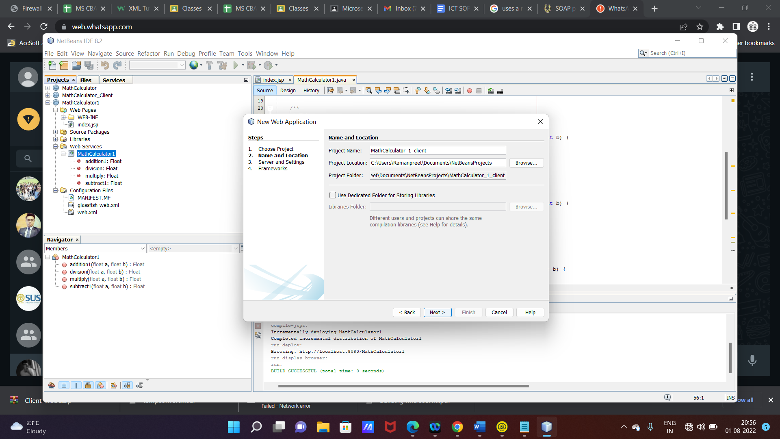

Create web service client

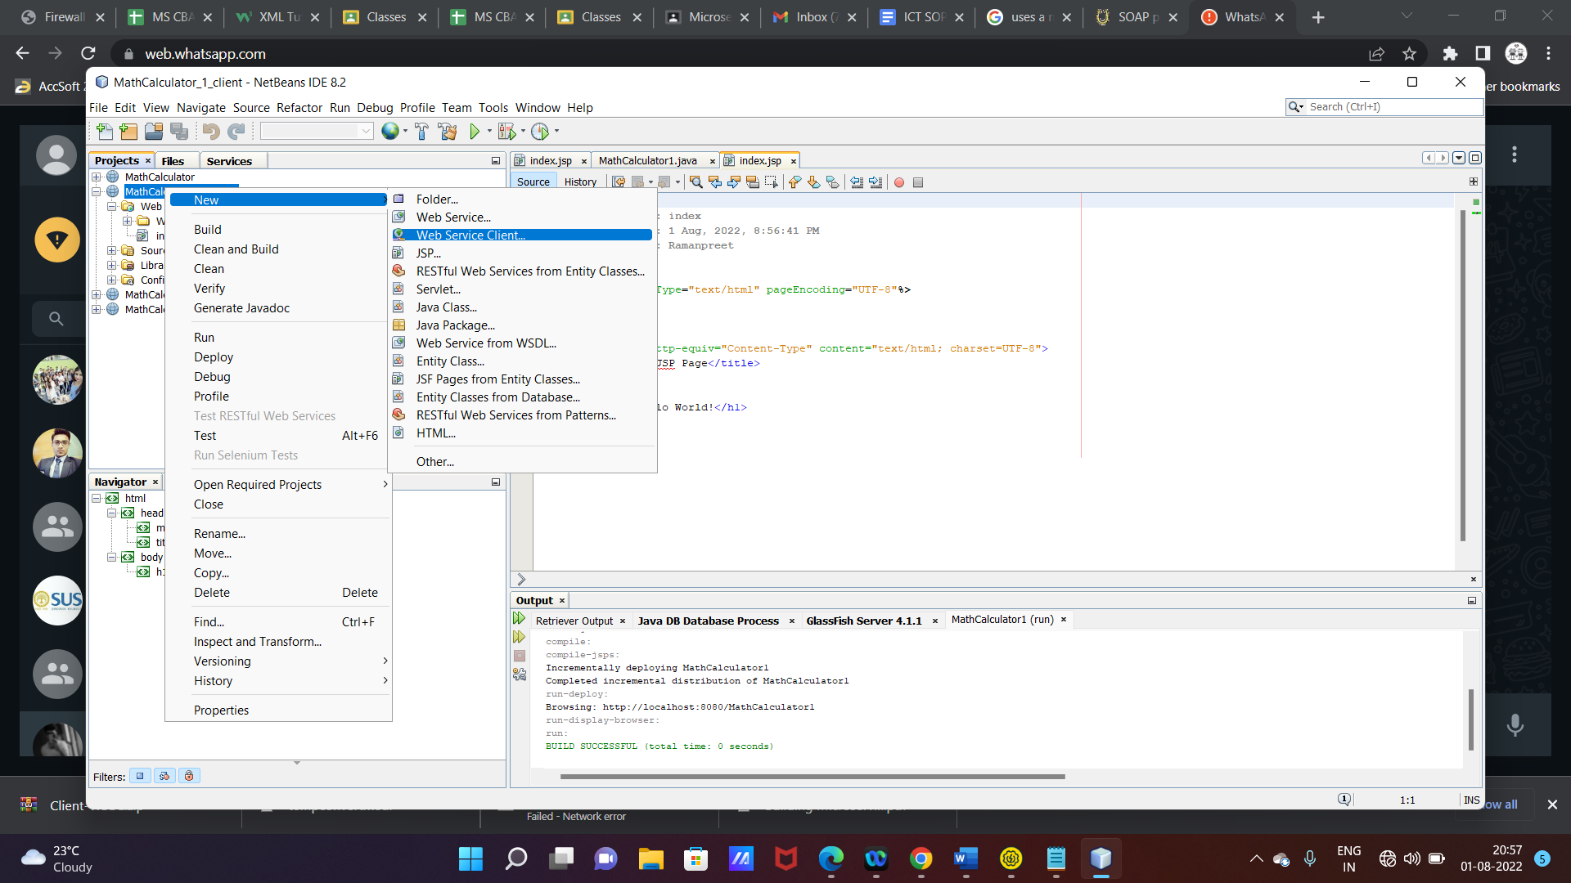

Paste wsdl file url copied in previous steps

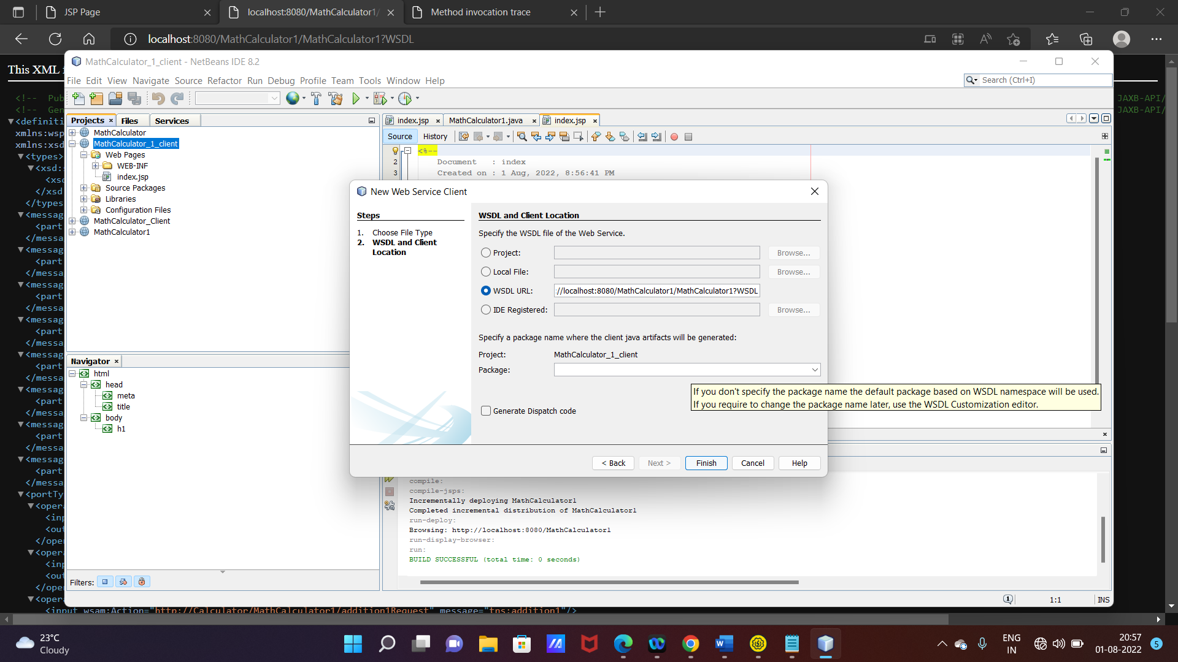

Make changes in JSP file of client web app

<form action="Calculate">

Enter a number :<input type="text" name="a">

<br>

Enter a number :<input type="text" name="b">

<br>

<input type="submit" name="type" value="addition1">

<br>

<input type="submit" name="type" value="subtract1">

<br>

<input type="submit" name="type" value="multiply">

<br>

<input type="submit" name="type" value="division">

</form>

PUT form in the body

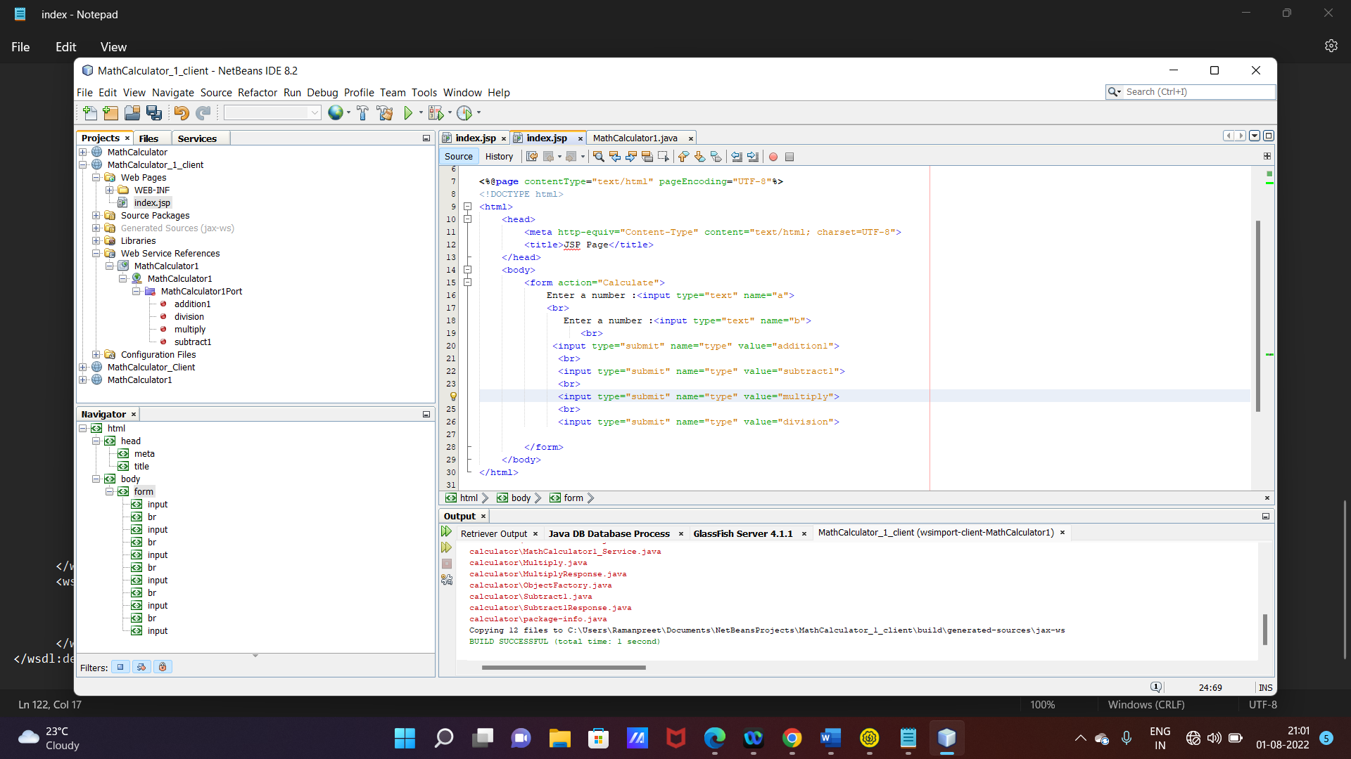

ADD functions to be invoked

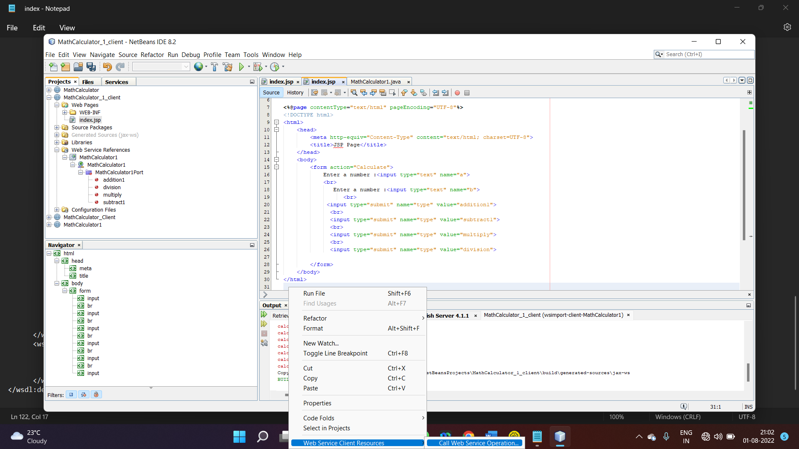

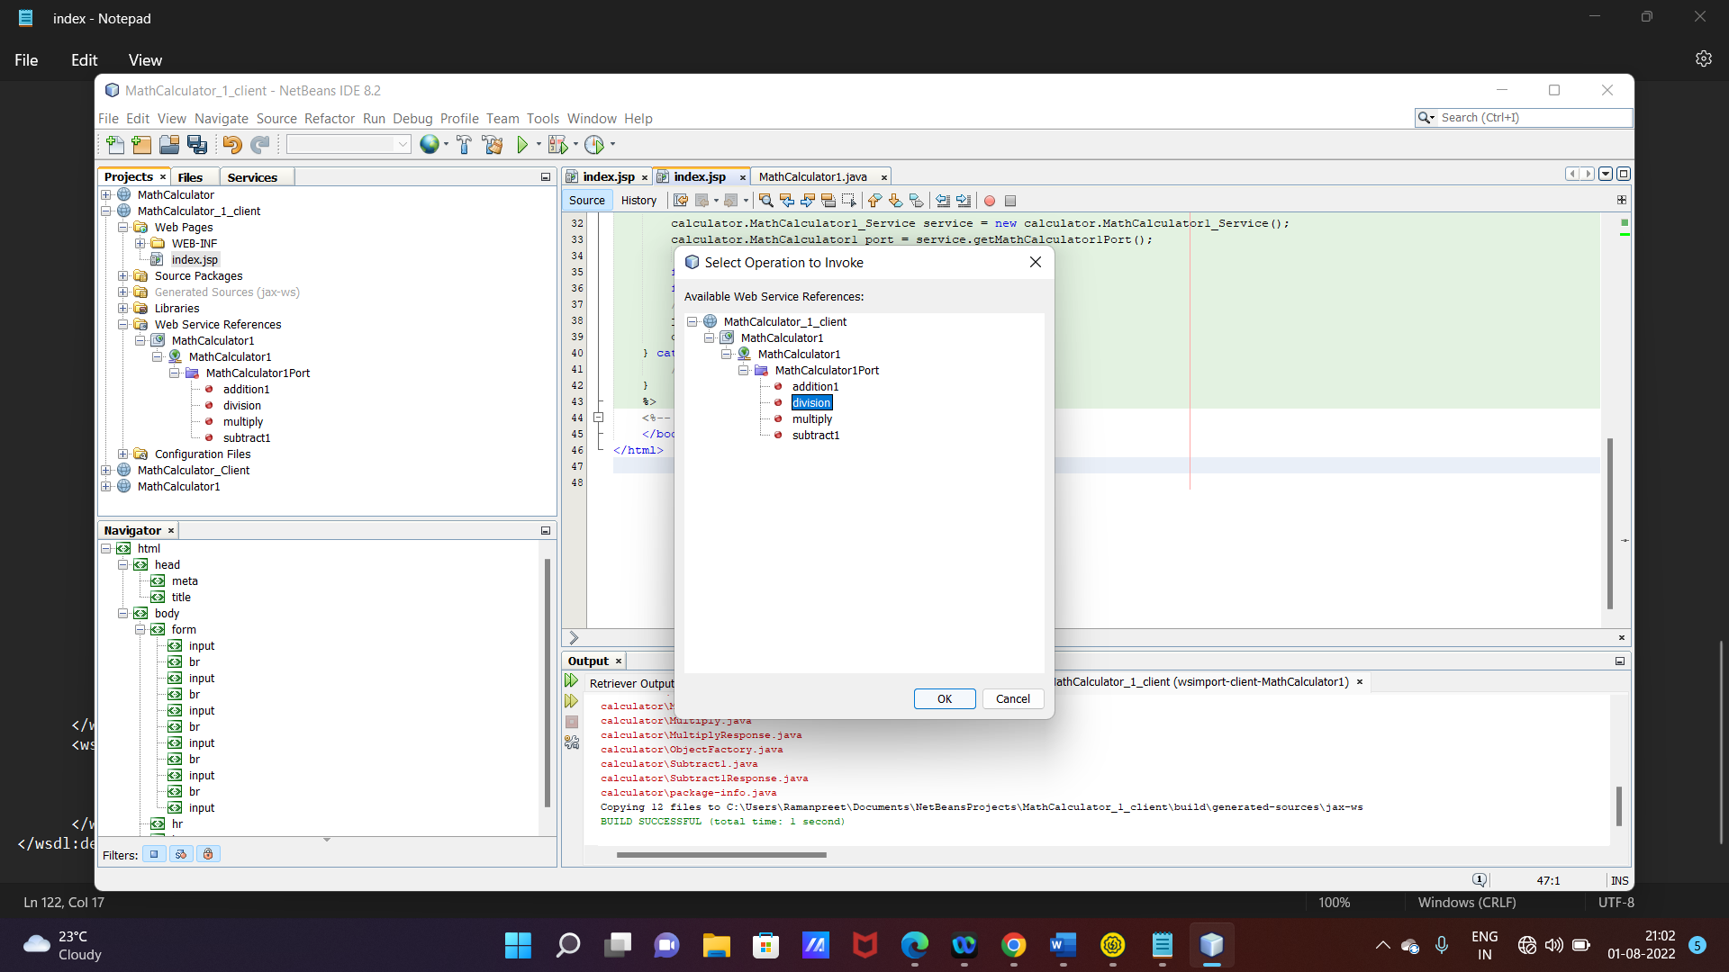

Do the required editing in all methods

Write index.jsp in form a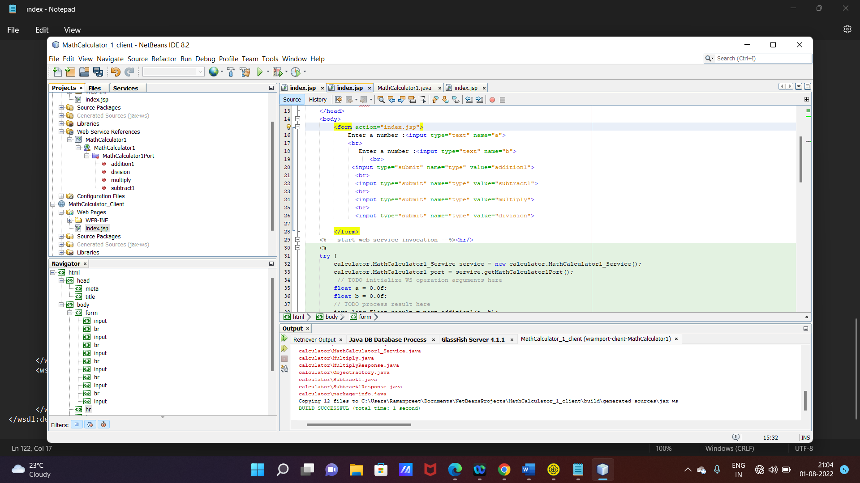ction

Changes in add method

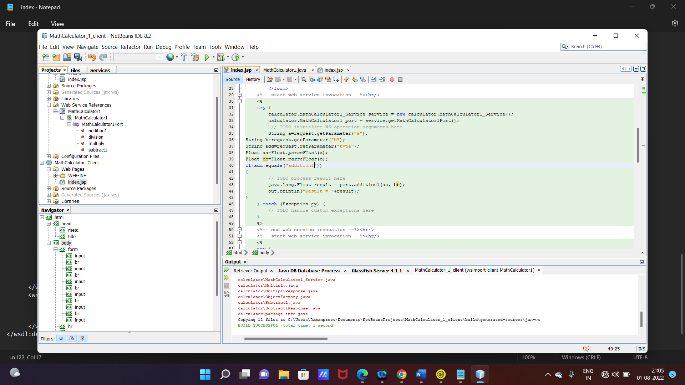

String a=request.getParameter("a");

String b=request.getParameter("b");

String add=request.getParameter("type");

Float aa=Float.parseFloat(a);

Float bb=Float.parseFloat(b);

if(add.equals("addition1"))

{

// TODO process result here

java.lang.Float result = port.addition1(aa, bb);

out.println("Result = "+result);

}

Changes in division method

String a=request.getParameter("a");

String b=request.getParameter("b");

String div=request.getParameter("type");

Float aa=Float.parseFloat(a);

Float bb=Float.parseFloat(b);

if(div.equals("division"))

{

java.lang.Float result = port.division(aa, bb);

out.println("Result = "+result);

}

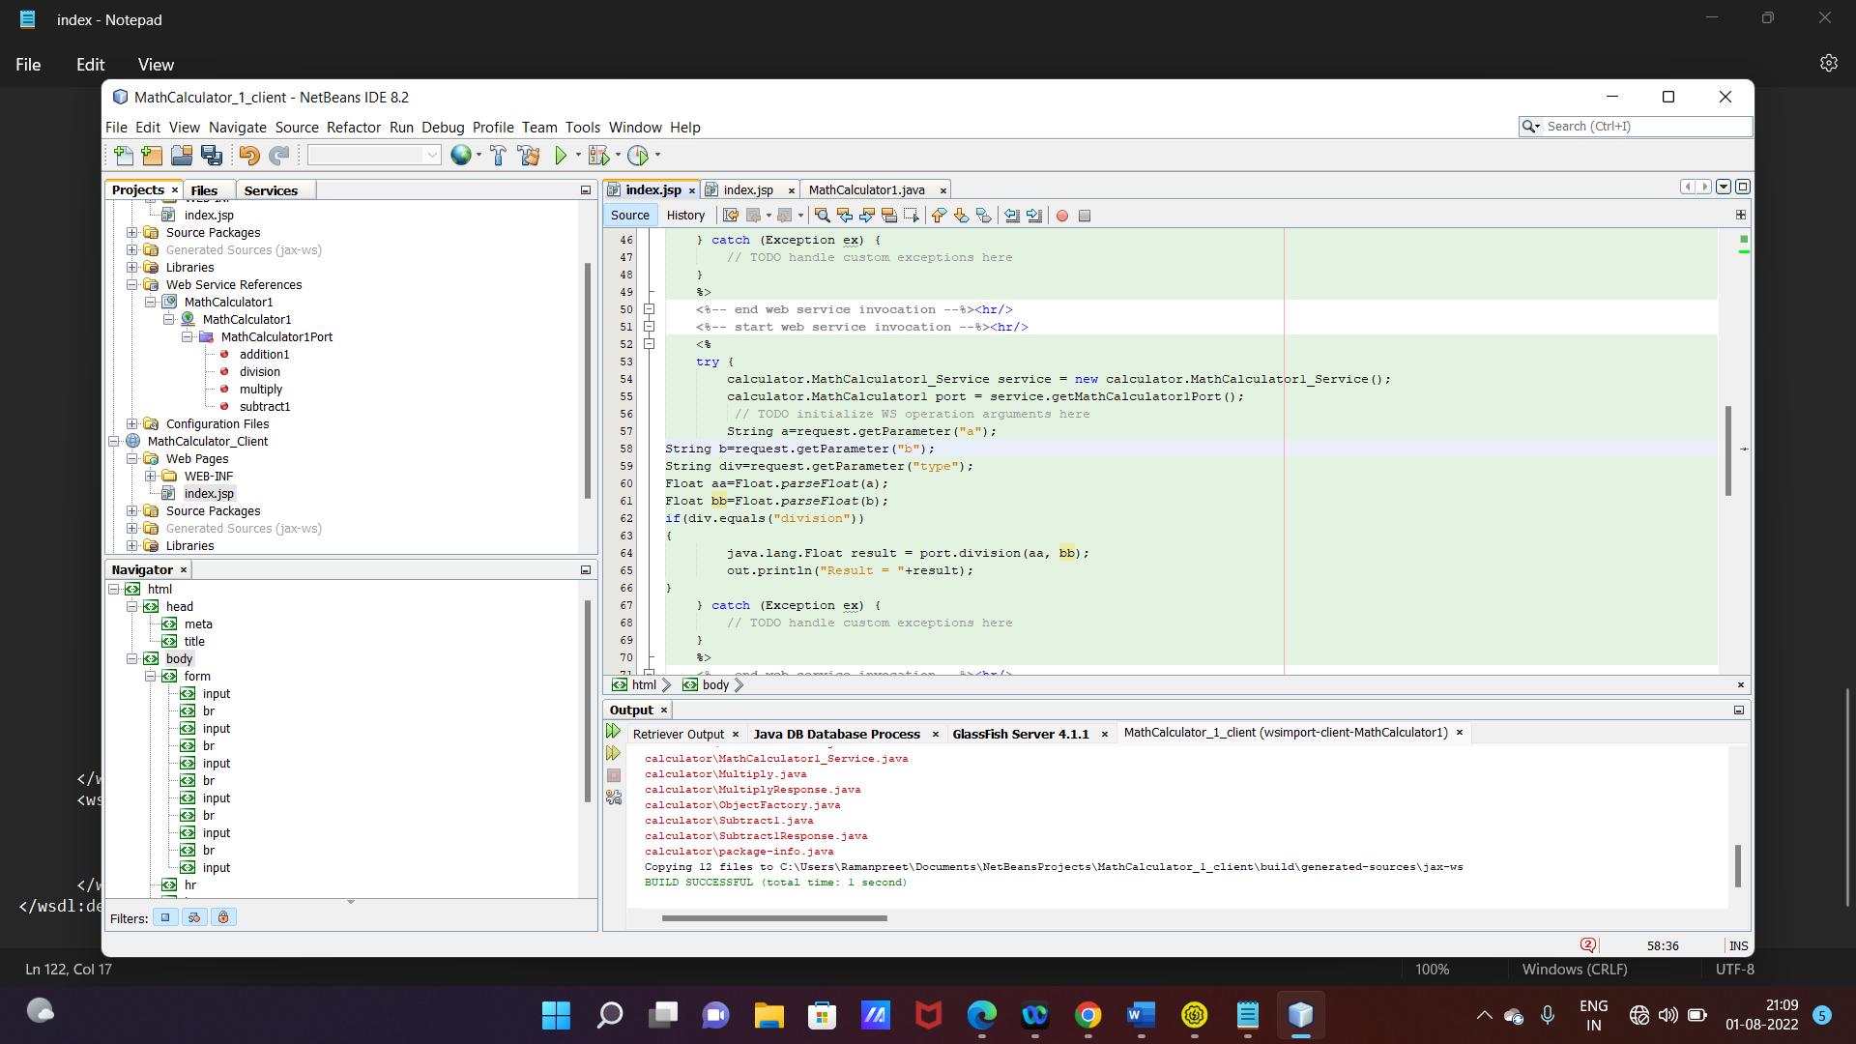

Similarly make changes in multiply and subtract

Deploy client web service

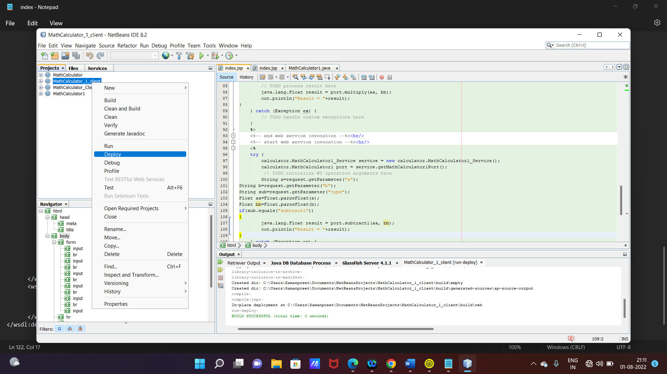

Run Project

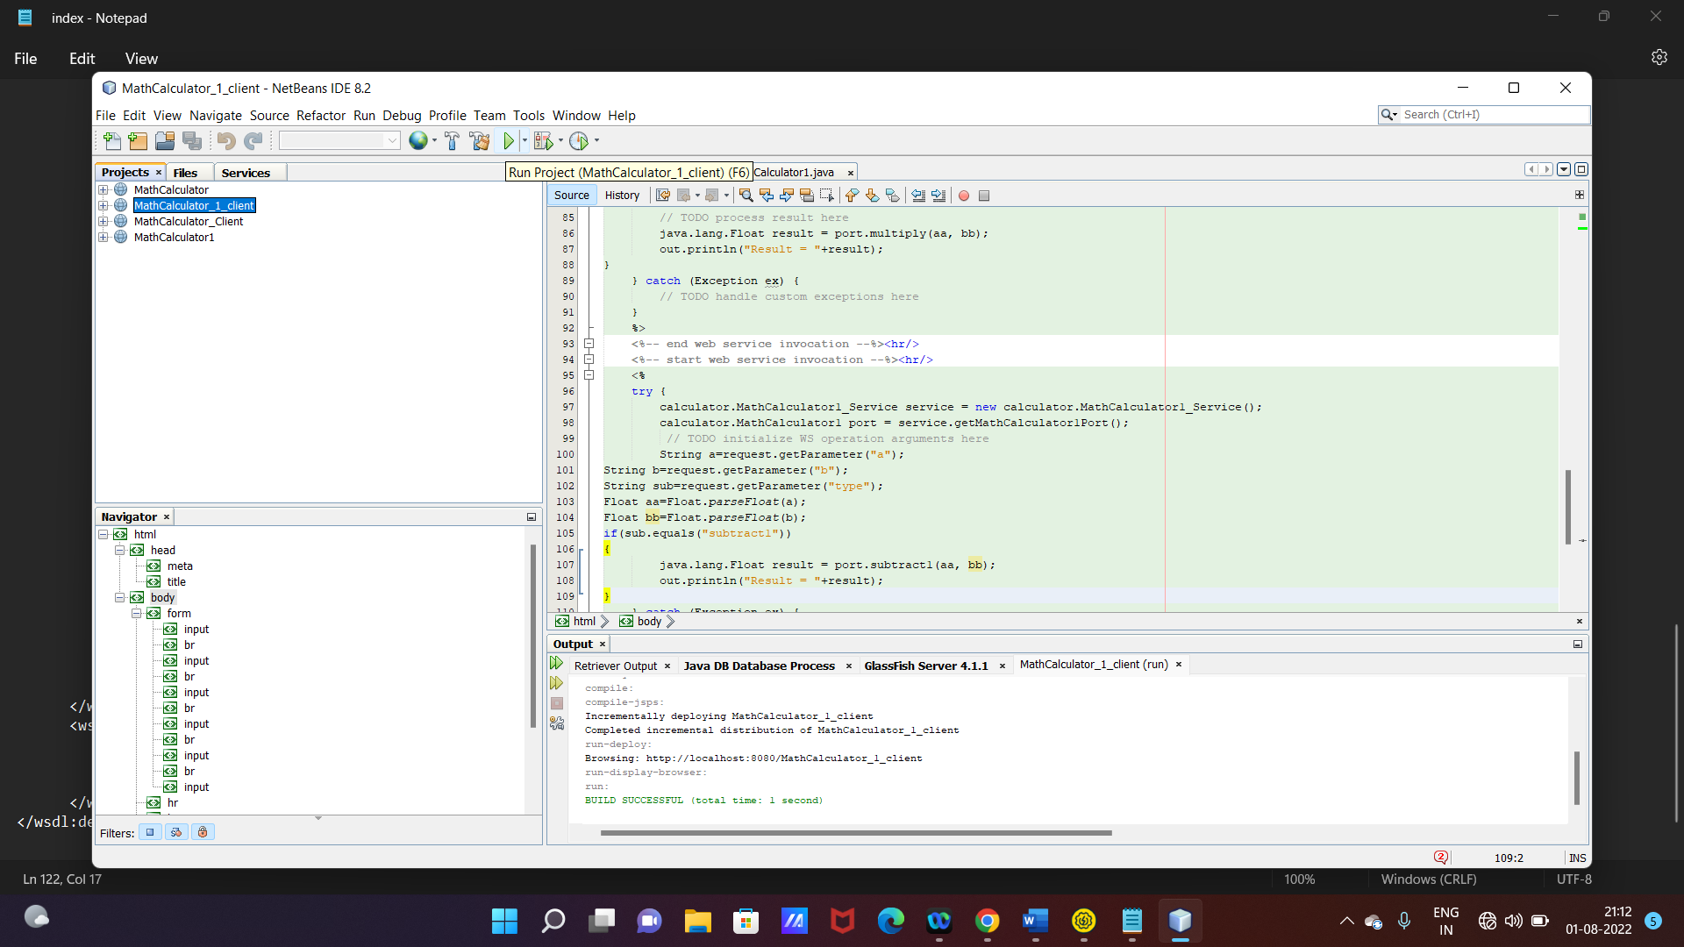

Final Output

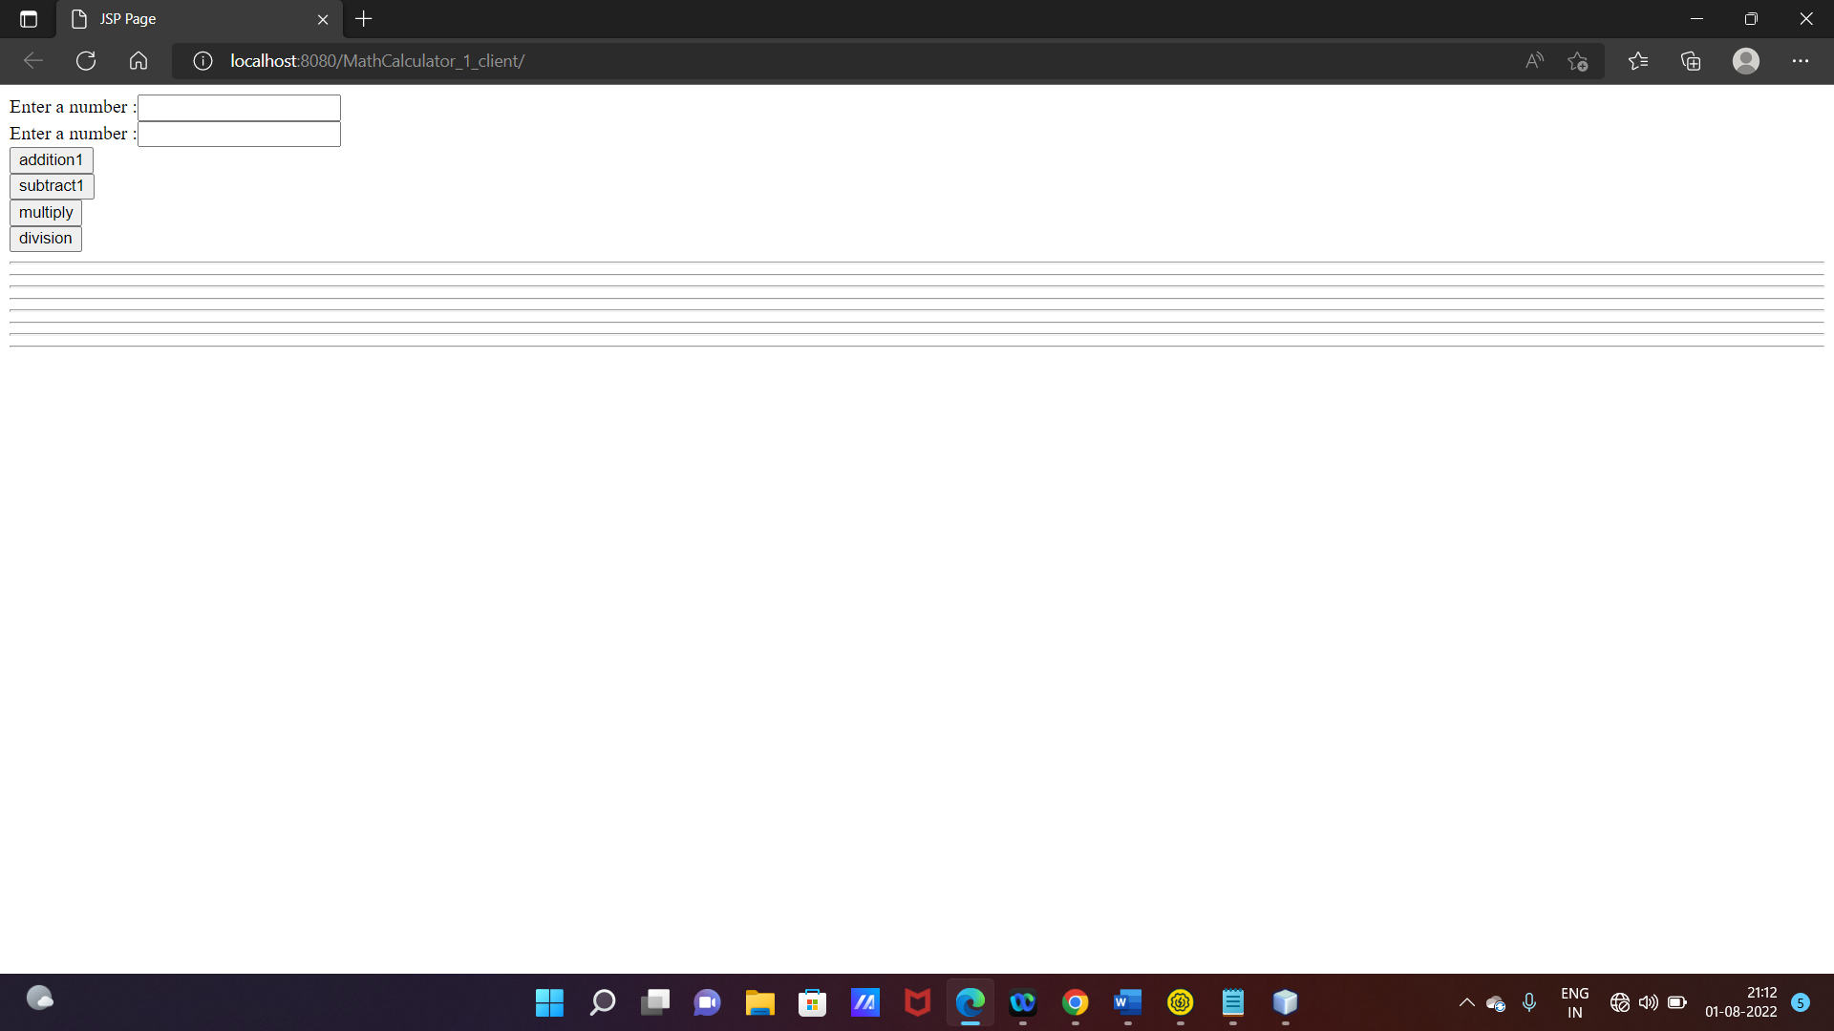

Test All operations

